Chapter 1-2 Notes

Deterministic diagraphs require arrows from the accept state, whereas non-deterministic diagraphs stop at the accept state

Deterministic Graphs cannot have a two letters that lead to the same state (e.g. 0 and 1 go from q4 to q5 is not allowed).

**Question 0: 010 would not be accepted**

**It would accept anything has 101 or 11 though**

**Question 2:**

**Q = {q1, q2, q3, q4}**

**Sigma = {0, 1}**

**delta =** 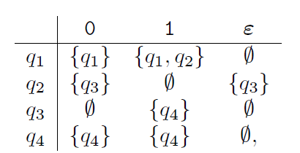

**q0 = q1**

**F = {q4}**

NFAs are equivalent to DFAs in terms of power, as they understand the same language. It’s just more compact in NFA form I believe.

**Question 3:**

**Q = {1, 2, 3}**

**Sigma = {a, b}**

**Q0 = 1**

**F = {1}**

**Question 4:**

**Q′ ={∅,{1},{2},{3},{1,2},{1,3},{2,3},{1,2,3}}**

**Question 5:**

**Sigma’ = {{a}, {b}, {a,b}, {a,c}, {b,c}, {a,b,c}**

**Question 6:**

**q’0 = {1,3}**

**Question 7:**

**F’ = { {1}, {1,2}, {1,3}, {1,2,3} }**

**Question 8:**

∅

∅

∅

∅

{2}

{2,3}

{3}

{1,3}

∅

{2,3}

{2,3}

{1,3}

{2}

{1,2,3}

{3}

{1,2,3}

{2,3}

δ'

**a**

**b**

∅

{1}

{2}

{3}

{1,2}

{1,3}

{2,3}

{1,2,3}

Now that we know about NFA’s, we can get back to unions, concatenations, and intersections.

**Question 9:**

**Q={𝑞0} ∪ Q1 ∪ Q2**